|  |  |
| --- | --- |
|  | |
| **UE 6.1 – Final Report**  **Sparse Radar Imaging Technique**  **FISE - 2021** | |
|  | ENSTA Bretagne  2 rue F. Verny  29806 Brest Cedex 9, France  First Lieutenant – French Procurement Agency  BARRET Maxime, [maxime.barret@ensta-bretagne.org](mailto:maxime.barret@ensta-bretagne.org)  06 33 33 82 26 |

Contents

Equations table 4

Illustration table 4

Introduction 4

I. Required notions 5

1. RADAR 5

1.1. History of Radar 5

1.2. Basic principle 6

1.3. Radar Equations 6

2. Radar Cross Section 7

2.1. Expression 7

2.2. Influential parameters 8

3. Sparsity 9

4. Radar Imaging Techniques 10

4.1. Doppler Effect 10

4.2. SAR 10

4.3. ISAR 11

II. Measurements acquisition 11

1. Anechoic chamber 11

2. Antennas and frequency range 12

3. Vector Network Analyser 13

4. Protocol 13

4.1. Measurement without target and calibration 13

4.2. Target placement and measurements 15

III. Sparse Radar Imaging TEchnique 16

1. Problem statement 16

2. SPRITE 16

3. Results 17

IV. Implementing Imaging Techniques 18

1. Generating data 18

2. ISAR (Fourier) 19

2.1. Distance analysis 20

2.2. Transversal analysis 20

2.3. Grid change 21

3. SPRITE 2D 22

3.1. 2D Implications 22

3.2. Choosing parameters 22

4. Image enhancement 23

5. Comparison 23

Conclusion 23

Bibliography 23

Annexe 23

# Equations table

Equation 1 - Basic Radar Principle 6

Equation 2 - Radar Range Equation 7

Equation 3 - Radar Equation (Monostatic) 7

Equation 4 - Radar Equation (Bistatic) 8

Equation 5 - Radar Cross Section definition 8

Equation 6 – RCS expressed in dBm² 8

Equation 7 - Spatial Resolution 13

Equation 8 - Optimisation problem for estimated scattering map 17

Equation 9 - Optimisation Criterion 17

Equation 10 - Ambiguity Window's size 19

# Illustration table

Figure 1 - Early German Warning Radar, Freya (1940) 6

Figure 2 - Illustration of the wave trajectory [3] 7

Figure 3 - Radar Cross Section diagram of a B-26 Bombardier – f = 3 GHz 9

Figure 4 - Image acquisition in different polarisations - PALSAR polarimetric image [5] 9

Figure 5 - B2 Spirit Bomber (left) and Languedoc Frigate (right) – Credits to Staff Sgt. Bennie J. Davis III and meretmarine.com 10

Figure 6 - Basic SAR operation 11

Figure 7 - ISAR image of an airplane 11

Figure 8 - SOLANGE anechoic chamber - DGA Maitrise de l’Information - Bruz 12

Figure 9 - Simplified VNA measurement process 13

Figure 10 - Comparison of the measured electric field in an empty anechoic room and with a small metallic arrow [9] 14

Figure 11 - Calibrating a chamber based on a 8 dBm² RCS sphere 15

Figure 12 - RCS of a square metal sheet estimated, and measured on a misplaced target. 15

Figure 13 - Picture of the cone / Simplified diagram of the measurement acquisition 17

Figure 14 - (a) Classical Approach / (b) l1-regularisation / (c) SPRITE 18

Figure 15 - Output of the gen_synth.m script – Frequency between 9 and 11 GHz, and 360° span 19

Figure 16 - Target considered 20

Figure 17 - Sine graph for the considered target (left) – for a target bigger than the ambiguity window (right) 20

Figure 18 - ISAR image of the target 21

Figure 19 - Data location approximations [8] 22

Figure 20 – ISAR after changing grids 22

# Introduction

The RADAR Cross Section is a measurement that indicates how detectable an object is by a RADAR and acts as an intrinsic electromagnetic signature to said object. The greater the RCS[1], the easier to detect hence the constant consideration of whether the object should be detected or should be stealthy. The RCS bears more information than just a surface, and given the right data, it can be used to classify and identify aircraft, ships, and so on.

With an anechoic chamber, conditions are optimal to fully quantify the RCS of an object according to the RADAR’s operating frequency, and the angle at which the RADAR’s beam hits the object. Given the data provided by the Vector Network Analyser, and using classical operations such as Fourier’s Transform, 3D representation of the object can be created. Such techniques have been known and implemented since the 1980’s. [1]

Yet, the aforementioned techniques can provide only moderate quality results. This project aims at implementing a version of the Sparse Radar Imaging Technique (SPRITE) that should give us better results. The sparse approach gives us access to new algorithms, and allows us to take less measurements, which is a plus considering how tedious acquiring them is.

In the first chapter, I will mention a few notions that are essential in order to comprehend the methods and results. Then, I will emphasize on the data acquisition process, followed by an in-depth description of SPRITE[2] and comparison to existing methods.

# Required notions

Before dwelling into how to generates images from RCS measurements, we must remind ourselves of a few basic principles and results.

## RADAR

### History of Radar

A radar is designed to emit an electromagnetic signal to “listen” out for an echo, to determine distance, location, and other characteristics of a target in its beam.

No scientist can actually claim to be the inventor of the Radar, as it is the accumulation of many technologies and scientific advancements in which several countries took a part. [2]

It all began with the work of James Clerk Maxwell, in which he demonstrated that electric and magnetic fields travel through space like waves, at the speed of light. Electromagnetic waves were discovered years later, by Heinrich Hertz, confirming Maxwell’s theories. At the beginning of the 20th century, Nikola Tesla hinted that EM[3] waves could be used to detect moving metallic objects. As time went by, numerous applications came to be, and inventions such as the magnetron and the klystron allowed nations such as the United States, the United Kingdom, Germany, Japan, and France to have Radars during World War II.

Figure 1 - Early German Warning Radar, Freya (1940)

Compared to visual observation, and optical systems, radar has many advantages: can be unmanned, operational day or night, in all weather, and through different technologies, can provide more than just detection.

### Basic principle

Even though the calculations and equations can be complex, the basic principle of a Radar is quite simple to grasp. An antenna sends an EM wave in a certain direction: If the wave encounters an object, it will scatter and eventually bounce back for the antenna to receive. Knowing that an EM wave propagates at the speed of light, and being able to measure the delay between emission and reception, the distance travelled by the wave can be computed. Thus:

Equation 1 - Basic Radar Principle

Where

* is the distance between the Radar and the target (m)
* is the speed of light ()
* is the delay between emission and reception of the wave. (s)

Figure 2 - Illustration of the wave trajectory [3]

Furthermore, if the direction of the emitted EM wave is perfectly known, in azimuth and elevation, the position of our target can be deduced, with a certain degree of resolution depending on intrinsic characteristic of our radar. [3]

### Radar Equations

The Radar range equation provides the most useful mathematical relationship for engineers and technicians to dimension a Radar. It accounts for the following:

* Radar system parameters (Antenna, frequency, power…)
* Target Parameters (Radar Cross Section)
* Background effect (Clutter, noise, interference, and jamming)
* Propagation medium (absorption and scattering)

In a general case, the radar range equation is:

Equation 2 - Radar Range Equation

Where

* is the maximum range of the radar (m)
* is the minimum power that can be detected by the Radar (W)
* is the Gain of the antenna used by the Radar (W)
* is the Radar’s operating frequency (m)
* is the Radar Cross Section of the target (m²)
* L characterises the loss due to background effect and the propagation medium

Rearranged, in a monostatic case[4], it becomes:

Equation 3 - Radar Equation (Monostatic)

Where

* is the power received by the Radar (W)
* is the power emitted by the Radar (W)
* is the distance at which the target is (m)

In a bistatic case,

Equation 4 - Radar Equation (Bistatic)

Where

* is the Gain of the antenna used by the emitting Radar (W)
* is the Gain of the antenna used by the receiving Radar (W)
* is the distance between the target and one radar (m)
* is the distance between the target and the other radar (m)

## Radar Cross Section

### Expression

In the previous equations, the Radar Cross Section was used, but was not defined properly. Expressed in m², the RCS[5] is a measurement that indicates how detectable an object is by radars. It is mathematically defined by:

Equation 5 - Radar Cross Section definition

Where

* is the backscattered electric field (V/m)
* is the incident electric field (V/m)

As indicated in Equation 4, the greater the RCS, the greater the power received by the antenna and thus the probability of detection. This raises concern as to whether the object is stealthy or is not. A greater RCS can be useful for an airplane or sailboat far at sea, granting them more chances to be detected. On the contrary, a smaller RCS grants airplanes/ships and other systems brings stealth, and a potential head start in an operational situation.

Given the ample range of values that the RCS can have, it is more often expressed in dBm².

Equation 6 – RCS expressed in dBm²

Figure 3 - Radar Cross Section diagram of a B-26 Bombardier – f = 3 GHz

### Influential parameters

The RCS of an object depends on an extensive number of parameters, ranging from its geometric shape, the material it is made of, as well as the EM wave polarisation. All these parameters are thoroughly chosen to ensure stealth or better detection right from the start. [4]

Radars often emit linear polarised waves, either vertical (V) or horizontal (H), and can receive “listen” in either polarisation. An EM wave may change its state of polarization upon interacting with matter. Hence if a radar is in a co-polarisation configuration[6], it could lose information on depolarising targets. To limit this loss, cross-polarisation[7] is used.

The importance of an EM wave polarisation can be simply understood by looking at a satellite image of the ground.

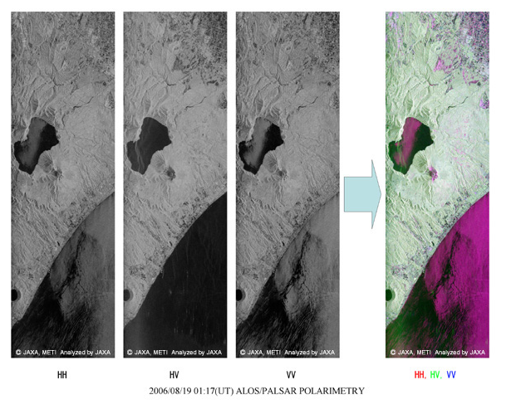

Figure 4 - Image acquisition in different polarisations - PALSAR polarimetric image [5]

On this image, we can see how the HV cross-polarisation contributes to the final reconstruction of the scene.

The material from which the target is made will be of utmost importance for its RCS. Radiation-absorbent material[8] is a material specially designed to absorb incident EM waves as effectively as possible. Such materials are used on aircraft and ships tending to be stealthy. [6]

For instance, the B2 bomber uses carbon-graphite material, and the latest French frigates use glass-resin composite to reduce the backscattered waves.

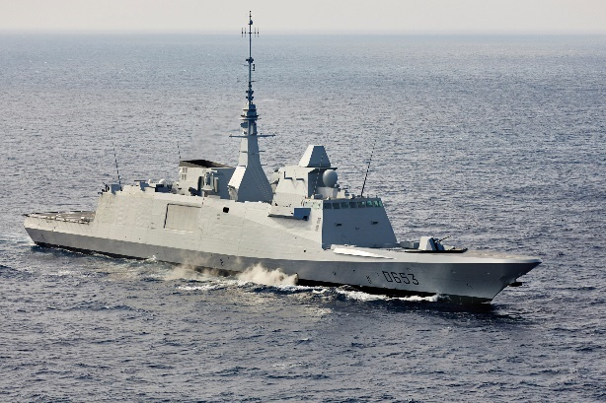

Figure 5 - B2 Spirit Bomber (left) and Languedoc Frigate (right) – Credits to Staff Sgt. Bennie J. Davis III and meretmarine.com

## Sparsity

The sparse representation of signal is a representation with a lesser number of significant parameters or values, the rest of them being equal to zero, or close to be.

When confronted with a linear problem that can be put into the following form such as , where D is a m by n matrix called the dictionary, x is a vector of length m, is a vector of length p, the core sparse representation problem is defined as the quest for the sparsest possible representation satisfying . For instance, a Matching Pursuit algorithm will look for a sparse representation or solution to the linear problem, one non-zero coefficient at a time. By doing so, a MP[9] algorithm will quickly give a good approximation of the solution, which will be sparse. [7]

Sparsity is a feat used also when the problem is ill-posed, i.e., there are too many unknown variables than the data allows us to compute exactly.

## Radar Imaging Techniques

As mentioned in the paragraph Radar, more than just the presence of a target or its distance can be extrapolated. Radars can be used to create 2D, or even 3D images of objects.

### Doppler Effect

When asked about the Doppler effect, which we can experience in daily life, an ambulance passing by. Is a typical example The pitch of the siren varies during time, because of the ambulance’s speed. The same thing happens with EM waves.

Radars transmit a signal to a target and receives an echo signal from it. Based on the time delay of the received signal, the radar can compute the target’s distance. If the target is moving, the frequency of the received signal will be shifted from the frequency of the transmitted signal: the Doppler effect. The Doppler frequency shift is determined by the radial velocity of the target. This shift is often measured in the frequency domain, by using the Fourier Transform.

### SAR

Synthetic-Aperture Radars are a type of radar used to create 2D images or 3D reconstructions of objects. Here, “object” is broad, as landscapes are often represented thanks to SAR[10]. SAR also stands for the airborne and spaceborne technique to create images remotely. It uses the motion of the radar antenna over a target region to provide finer spatial resolution than conventional beam-scanning radars. The first SAR images were formed when a C46 aircraft was to map a section of Key West in Florida. [6]

A SAR works just like a regular radar except that it is moving but given that its trajectory is most likely known[11], we can account for the doppler shift induced and correct it after the fact: this allows us to recreate images of the scanned scene.

SAR imagery is based on successive signal processing algorithms called range compression and azimuth compression. [7]

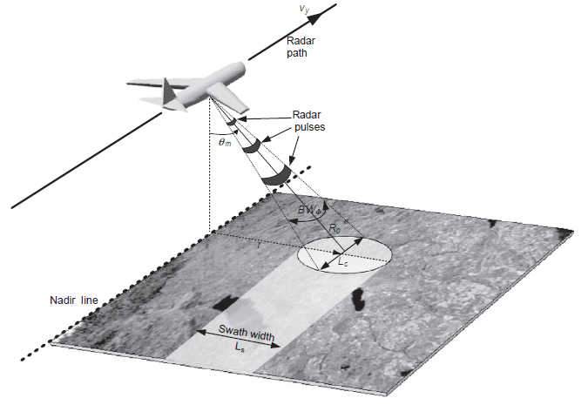

Figure 6 - Basic SAR operation

### ISAR

Inverse Synthetic Aperture Radar is a signal processing technique for imaging moving targets. An ISAR image has the ability to display the scattering ‘hotspots’ of a target. Unlike SAR imaging, the radar is stationary, and the target is moving. As indicated by the names, SAR and ISAR can be similar on some aspects, and a spotlight SAR geometry with a circular path is analogous to ISAR geometry. [8]

Figure 7 - ISAR image of an airplane

# Measurements acquisition

To reconstruct an image, data must be acquired. We can begin to work with simulated data, but the model used may not account for natural phenomena occurring that potentially decreasing the quality of the reconstruction. To get a better look at the RCS of an object, an anechoic chamber is the ideal tool.

## Anechoic chamber

An anechoic chamber is a room in which only the electric field scattered by the object of interest is obtained. No anechoic chamber is alike. Indeed, each one is defined by a certain number of parameters that will determine the characteristics of the chamber. For instance, depending on what we ought to measure, the size of the chamber will be different. *Solange,* located in Bruz, can house 1:1 representation of combat aircrafts or drones, whereas ENSTA Bretagne’s chamber is limited to small objects.

Figure 8 - SOLANGE anechoic chamber - DGA Maitrise de l’Information - Bruz

Other parameters include:

* Measurement configuration: monostatic, bistatic, quasi monostatic
* Polarisation of the incident wave
* Measurement Frequency range
* The target’s mass
* The maximum expected RCS [9]

The wavelength of the incident wave will also be decisive on the shape and size of the foam used on the wall. The purpose of this specially coated foam is to limit reflection of the walls and mounting mechanism that will pollute the acquisition as much as possible. With the help of a carbon-rich paint and its pyramidal shape, the foam acts as a wave trap and dissipate waves through Joule heating. [10]

## Antennas and frequency range

Once the chamber has been designed as intended, the choice of the antennas and the layout that will be relevant for the measurements must be made. We will have to keep in mind that to get co-polarisation as well as cross-polarisation, a particular antenna must be used. As for the layout, we have the choice between monostatic, quasi monostatic, and bistatic. Here at ENSTA Bretagne, users can choose from bistatic and quasi monostatic:

Two horn antennas are disposed on a rail, facing the mounting mechanism for the measured object.

Horn antennas can operate over a wide range of frequencies, which is critical since the anechoic chamber in ENSTA Bretagne must operate from 2 GHz[12] to 18 GHz. [11]

The resolution at which the measurement chain can operate is directly linked to this frequency range, such that:

Equation 7 - Spatial Resolution

Where

is distance resolution (m)

is the speed of light ()

is the frequency range (Hz)

## Vector Network Analyser

The VNA[13] compares the incident signal, which it generates, to the received signal, which was scattered by the measured object. The value resulting from this comparison is complex and called the S-parameter. The S-parameter is complex because, unlike a Scalar Network Analyser, the VNA not only measure the amplitude, but also the phase of the received signal.

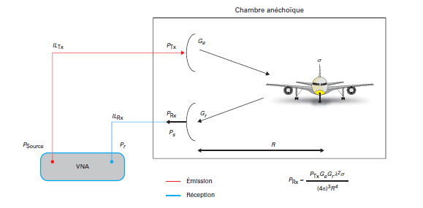

Figure 9 - Simplified VNA measurement process

To link the VNA and the antennas, coaxial cords are often used. Every connection between components must be considered as each link of the chain generates power loss depending on the frequency.

Just as with the anechoic chamber, the VNA must be chosen considering certain parameters such as:

* Frequency range
* Maximum power delivery for the incident wave
* Maximum received power
* The receiver’s Johnson–Nyquist noise (or thermal noise)

## Protocol

### Measurement without target and calibration

Even though an anechoic chamber aims to minimise the reflections of EM waves on the walls, it is impossible to guarantee that parasites signals will not be included in the measurements. Furthermore, the measurement chain will most certainly bring its own noise: hence the need to evaluate the levels of noise beforehand.

By measuring the electromagnetic signature of the room, without any target, those values can be subtracted in order to minimise the noise levels and get more accurate readings.

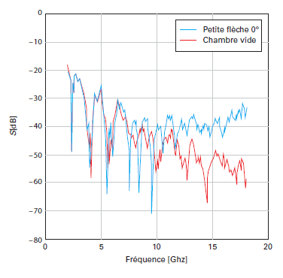

Figure 10 - Comparison of the measured electric field in an empty anechoic room and with a small metallic arrow [9]

According to Figure 8, at some frequencies, electric field levels can be very similar with or without our target. The electric field measured in the chamber is subtracted in a vectorial way, such that the phase of the electric field is also subtracted.

In addition to the measurement without a target, the measurement equipment also must be calibrated based on a perfectly known target according to the Geometrical Theory of Diffraction. For instance, we can use a metal plate or a metal sphere, precisely positioned on the pedestal. For common and simple geometric shape, the GTD[14] gives us a standard to go by, and most importantly a correction coefficient to apply to the measurement following this calibration phase.

Every measurement campaign starts with this phase, only then can we place our target on the pedestal.

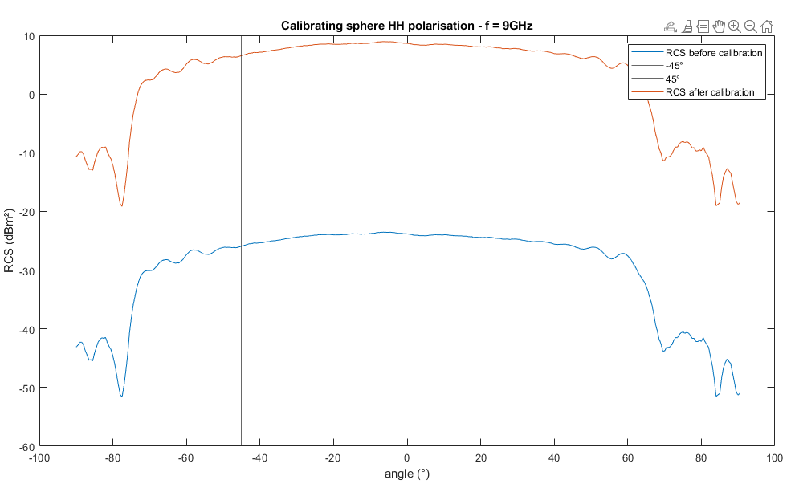

Figure 11 - Calibrating a chamber based on a 8 dBm² RCS sphere

### Target placement and measurements

The placement of the target is of the essence because its backscattered field and thus its RCS greatly depends on the angle of the incident wave. Misaligning the target could lead to poor results, an offset for instance. The first step is the alignment of the object with the beam of emission of our antenna, and make sure its angle is relevant to what we ought to measure.

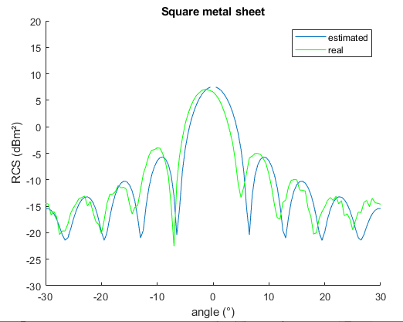

Figure 12 - RCS of a square metal sheet estimated, and measured on a misplaced target.

When in place, the measurement campaign can finally begin. In ENSTA Bretagne’s anechoic chamber, thanks to the 3 motors included in the pedestal, we can make our target spin on two axes (list and bearing) and translate on another (vertical). At a given angle, the antenna will emit as many times as necessary at various frequencies, and the scattered electric field will be measured by the receiving antenna. All of this is monitored and handled by a GUI[15] on a PC, which is connected to the VNA.

At the end of the measurement campaign, we end up with a matrix containing the amplitude and phase of the backscattered electric field. By using techniques such as ISAR, we will be able to reconstruct a 2D representation of our target.

# Sparse Radar Imaging TEchnique

Radar imaging is often an ill-posed problem: the number of unknows is larger than the amount of data. Conventional and common methods use data reformatting in the form of zero-padding to compensate and be able to apply inverse Fast Fourier Transform, giving adequate results. Yet, by using sparse representation algorithm, and extending the concept of scatter points, researchers were able to produce high resolution RCS imaging. [12]

## Problem statement

The acquisition method is the same as depicted in *Protocol,* we end up with a RCS matrix, that we will call .

We have:

Where

* is the model matrix
* is a noise vector
* is scattering map, which is the RCS

Given the fact that the problem is ill-posed, H is rank deficient and thus non-invertible: it is mandatory to regularize the problem that means consider prior information on the scattering map. *l1-regularisation* methods with the scattering map l1 norm a sparse promoting penalty, Orthogonal Matching Pursuit, and MUSIC[16] spectral estimation can be used, and give consistent results: the scattering map is composed of scattering hotspots.

In a high frequency context, specular reflections are the main scattering mechanisms, and not diffusion: scattering hotspot do not particularly account for those phenomena, which is why SPRITE introduced scattering segments and facets.

## SPRITE

SPRITE comes with 5 priors that are crucial:

* The vertical projection of the scattering map a is sparse.
* Specular facets are topologically connected, and the scattering coefficient is constant over each facet.
* The associated penalties are of l1-norms of a denoised by anisotropic total variations.
* The criterion is strictly convex.
* The EM extent of the target is of finite support.

According to those priors, the equation is as follows:

Equation 8 - Optimisation problem for estimated scattering map

with

Equation 9 - Optimisation Criterion

To solve this optimisation problem, SPRITE uses Alternating Direction Method of Multiplier (ADMM). This method is well adapted to strictly convex optimisation criteria: combined with the priors, ADMM mathematically ensures that our optimisation will converge. During the ADMM loop, nullifying the gradient is a matter of linear algebra, and considering that a lot of the matrices involved are either shift matrices, diagonal, or circulant, the calculations are quicker. Furthermore, the scattering map update is computed very efficiently in the frequency domain by FFT and IFFT[17].

## Results

ADMM ensured convergence thanks to the algorithms and criterions chosen. Figure 13 illustrates how researchers compared SPRITE to other methods. In an anechoic chamber, a metallic Perfectly Electrically Conducting (PEC) right circular cone is placed, pointing towards the antenna, in a monostatic configuration. On this cone are placed 6 rounded patches, that will be the scatterers to detect and map.

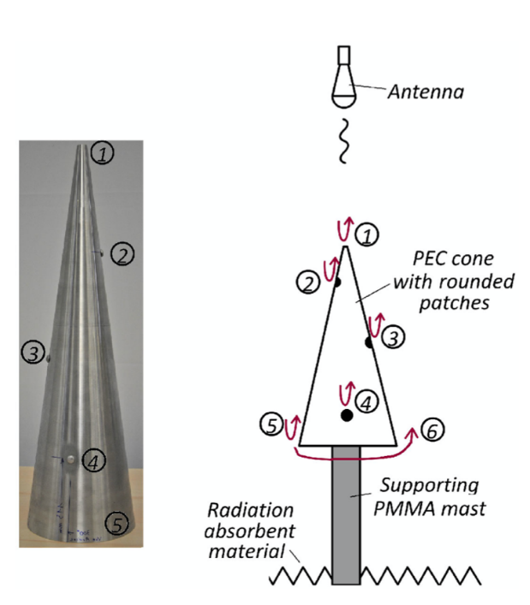

Figure 13 - Picture of the cone / Simplified diagram of the measurement acquisition

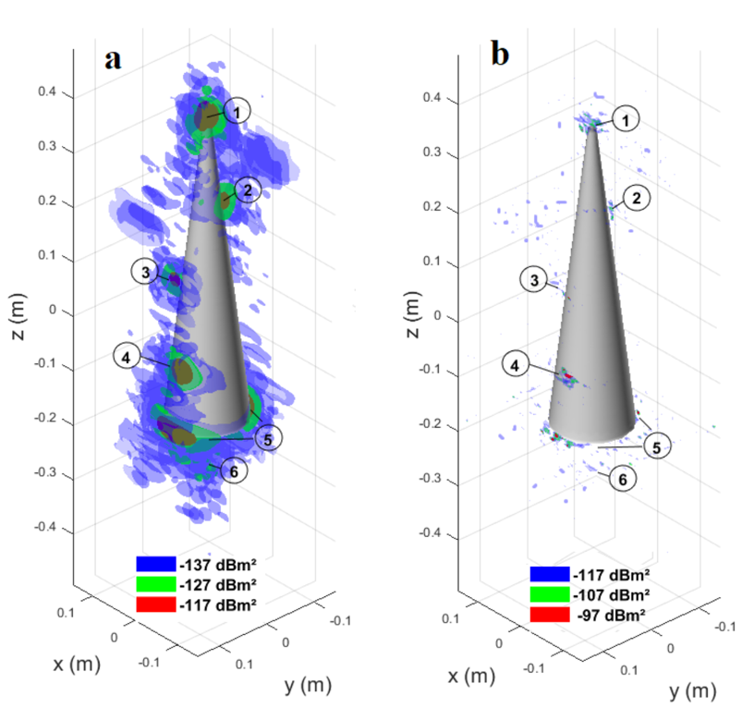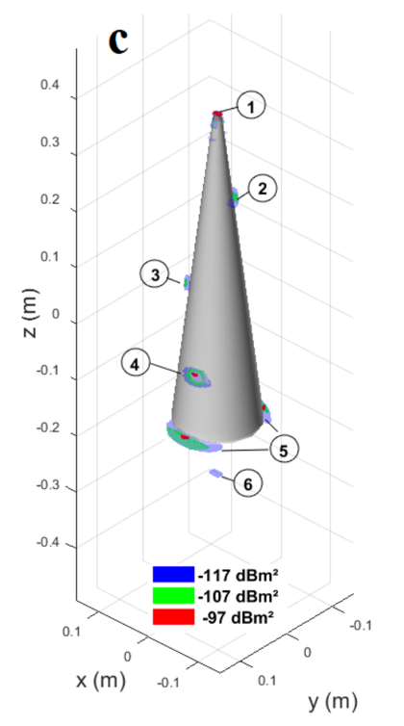

Figure 14 - (a) Classical Approach / (b) l1-regularisation / (c) SPRITE

A good result would be a 3D mapping only of the scatter points. According to *Figure 14***,** the classical approach does not bode well in this particular situation, with low power levels and noise everywhere. When looking at the l1-regularisation method, the benefits of a sparse approach are easily observed: better power levels and more localised hotspots. Finally, SPRITE gives us a sparse map that perfectly reflects the patches position.

# Implementing Imaging Techniques

## Generating data

The algorithm detailed in the previous part need to be verified with proper data. At first, simulated data will be provided by a MATLAB® script, courtesy of Fabrice COMBLET, Ph.D. Given parameters such as the frequencies and angles required for the acquisition process, this script generates a measurement based on the bright spots model. This will allow for an easy verification of the following methods by overlaying the spots map and the results.

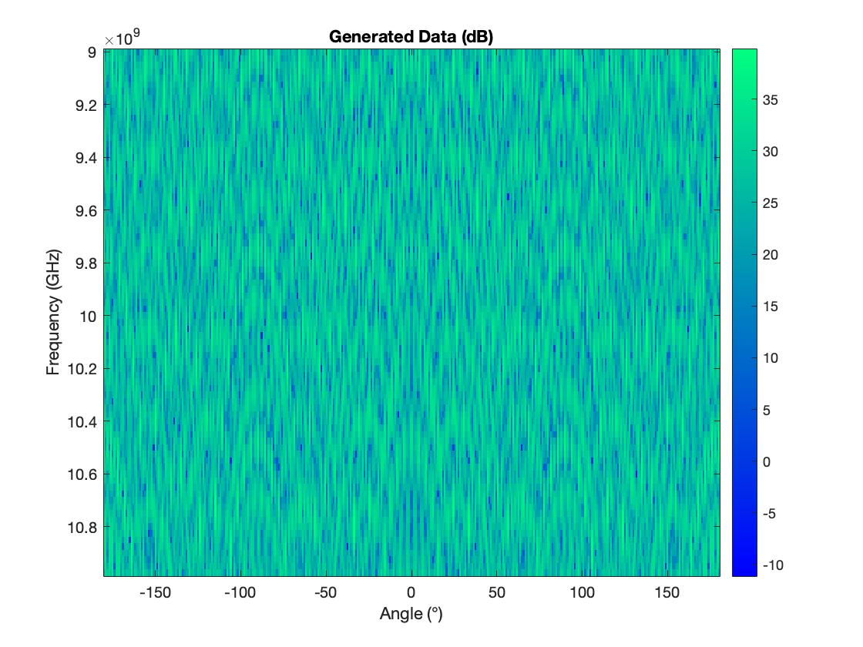

Figure 15 - Output of the gen_synth.m script – Frequency between 9 and 11 GHz, and 360° span

As described in II. *Measurements Acquisition*, the frequencies chosen must satisfy the spatial resolution desired.

Any data processing and results will be extracted from a MATLAB® notebook. The following results were obtained with the frequencies between 8 and 12 GHz.

## ISAR (Fourier)

In order to implement and illustrate how to obtain an ISAR image of a target described by its bright spots, the size of the ambiguity window must be greater than the actual size of the target to avoid aliasing, a criterion similar to Shannon’s. The width and height of this window are given by:

L  ; WT =

Equation - Ambiguity Window's size

Where

* is the width of the ambiguity window
* is the speed of light ()
* is the frequency step
* is the mean frequency of the acquisition
* is the bandwidth

Considering this window, the target will be:

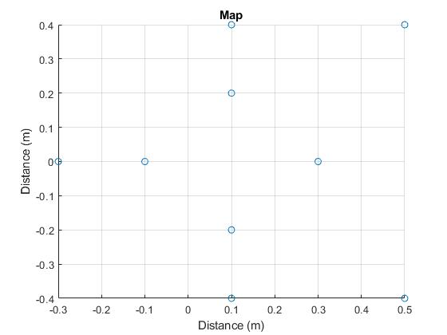

Figure 16 - Target considered

### Distance analysis

The first step of the Fourier approach is to compute a range profile for the target out of the data, for each of the angles considered, thanks to an IFFT. This inverse transformation is used because the data provided is in the frequency domain rather than the temporal one.

By doing so, the sine graph is constructed:

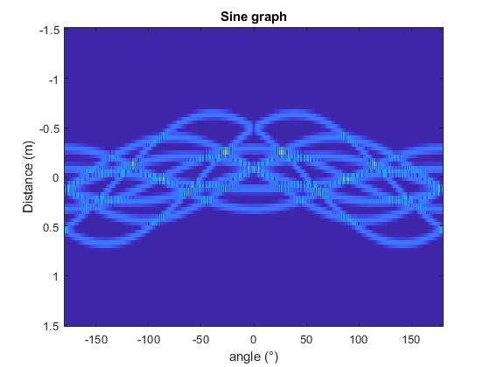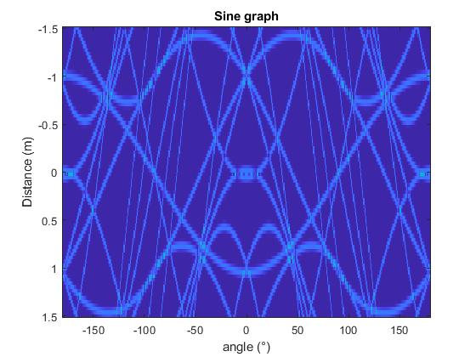

Figure 17 - Sine graph for the considered target (left) – for a target bigger than the ambiguity window (right)

In addition to respecting the size of the ambiguity target, a weighing window such as Hamming’s can be added to the data to improve the sine graph.

### Transversal analysis

The problem is now considered to be in a SASB[18] context. Thus, a narrow angle zone is used for the transversal analysis.

The selected part of the sine graph is then converted back in the frequency domain with an FFT, finally revealing the ISAR image within the ambiguity window. Given the definition of the Fourier Transforms on MATLAB®, the image must be rotated to fully match the original layout of the bright spots.

Figure 18 - ISAR image of the target

Overlayed on the image is the actual disposition of the target’s bright spots. We can see that the image is quite blurry around the alleged bright spots. Please note that this image is exempted of any noise. The zones on the right of the image appear to spread too much afar the true position of the bright spots. This anomaly can be fixed by changing the data’s grid.

### Grid change

By switching from the polar representation of the data to a cartesian, regular grid, the image can be enhanced. Indeed, the data acquired corresponds to a distance and an angle, yet the image striven to be obtained is represented on a cartesian grid. The difference between the two grids can induce errors and visual artifacts such as the ones on Figure 18.

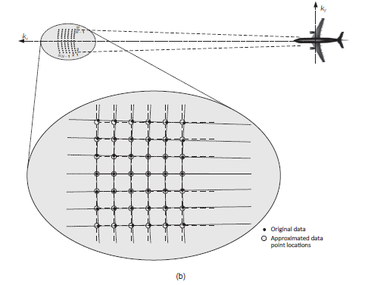

Figure - Data location approximations [8]

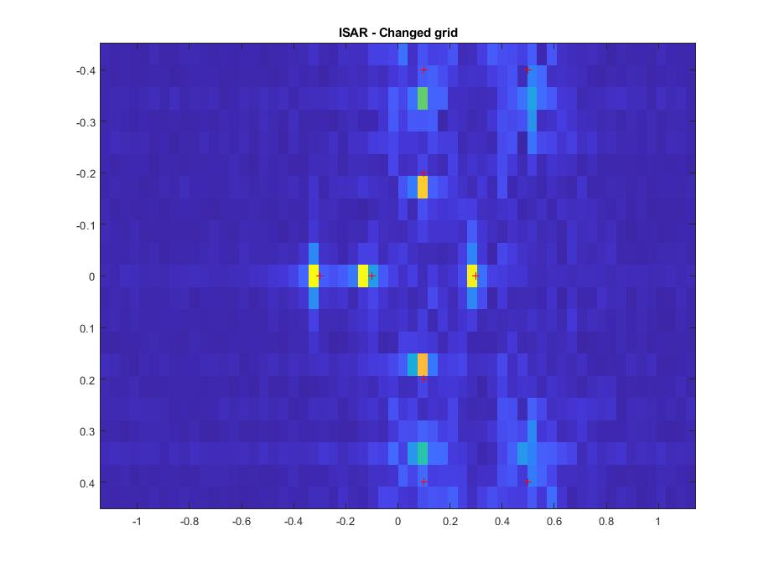

Figure 20 – ISAR after changing grids

Compared to Figure 18, we can see that the has fewer artefacts around the bright spots, as well as no remaining curvatures.

## Sparse Methods

Sparse approximations allow for new ways to solve equations. These methods well suit the bright spots model.

### Inverse problem formulation

As explained in 3. Sparsity, to use sparse approximation algorithms, the problem must be expressed such that:

is the original data acquired, that will simply be vectorised for formulation purposes. At any given time, it is possible to switch from the original data to its vectorised form and backwards with the *reshape* function on MATLAB.

The goal is to compute a scattering map a and reconstruct it from the model **H** and the measurements.

**H** = *α* *  *  * *S* * *F* * 

### Tikhonov

### Orthogonal Matching Pursuit

## Image enhancement

### Windowing

### Regrid (doublon)

### Deconvolution

## Comparison

# Conclusion

The purpose of this status report is to introduce the notions that are crucial to understanding the underlying principles of Radar, RCS, and imaging. After explaining how the Sparse Radar Imaging Technique operates, we had the opportunity to see that the results were as good as advertised by the researchers, even compared to other sparse representations.

We will implement this technique on MATLAB®, replicate the results and assess its performance compared to more common approaches, on simulated data as well as real data.

# Bibliography

|  |  |
| --- | --- |
| [1] | D. L. Mensa, High Resolution Radar Cross-Section Imaging, Boston: Artech House, 1991. |
| [2] | Y. Blanchard, Le radar, 1904-2004 : Histoire d'un siècle d'innovations techniques et opérationnelles, Ellipses, 2004. |
| [3] | C. Wolff, “radartutorial.eu,” 11 2020. [Online]. Available: https://radartutorial.eu. [Accessed 11 2020]. |
| [4] | J. F. S. M. T. T. Eugene F. Knott, Radar Cross Section - Second Edition, 2004. |
| [5] | J. A. E. A. (JAXA), “Advanced Land Observing Satellite (ALOS) -,” 1997. [Online]. Available: https://www.eorc.jaxa.jp/ALOS/en/index.htm. [Accessed 16 12 2020]. |
| [6] | F. Auzanneau, “Furtivité Electromagnétique,” *Techniques de l'ingénieur,* 2011. |
| [7] | A. D. &. C. Vanwynsberghe, “Sparse Representation and Compressed Sensing,” Brest, 2020. |
| [8] | C. Özdemir, Inverse Synthetic Aperture Radar Imaging with Matlab algorithms, Mersin, 2012. |
| [9] | J. Z. A Pasmurov, Radar Imaging and Holography, 2005. |
| [10] | M. M. Victor C. Chen, Inverse Synthetic Aperture Radar Imaging - Principles, Algorithms and Applications, Scitech Publishing, 2014. |
| [11] | F. D. C. E. J.-M. G. P. M. G.-P. P. Fabrice Comblet, “Mesure de la Surface Équivalente Radar - Aspect expérimental,” Techniques de l'Ingénieur, 2018. |
| [12] | ETS LINDGREN, TOP 10 ANECHOIC ABSORBER CONSIDERATIONS, Cedar Park, TX, 2019. |
| [13] | P. Dumon, “Antennes,” Toulouse, 2020. |
| [14] | J.-F. G. a. P. M. Thomas Benoudiba-Campanini, SPRITE: 3-D SParse Radar Imaging TEchnique, IEEE, 2020. |
| [15] | T. Benoudiba-Campanini, “Approche parcimonieuse pour l’imagerie 3D haute,” Université de Bordeaux, 2018. |

# Annexe

1. Radar Cross Section
2. SParse Radar Imaging TEchnique
3. Electromagnetic
4. Only one radar emitting and receiving
5. Radar Cross Section
6. HH or VV: Emitting and receiving in the same polarisation.
7. HV or VH: Emitting in a certain polarisation and receiving in the other.
8. RAM for short
9. Matching Pursuit
10. Synthetic Aperture Radars
11. Global Navigation Satellite Systems and Inertial Measurement Units used together provide tremendous precisions
12. ENSTA Bretagne’s chamber is NOT a Faraday cage, Wi-Fi and Bluetooth from nearby offices can and will ruin measurements
13. Vector Network Analyser
14. Geometrical Theory of Diffraction
15. Graphical User Interface
16. Multiple Signal Classification
17. Fast Fourier Transform and its inverse transformation.
18. Small Angle Small Bandwidth